Smart Trash Bin

* ***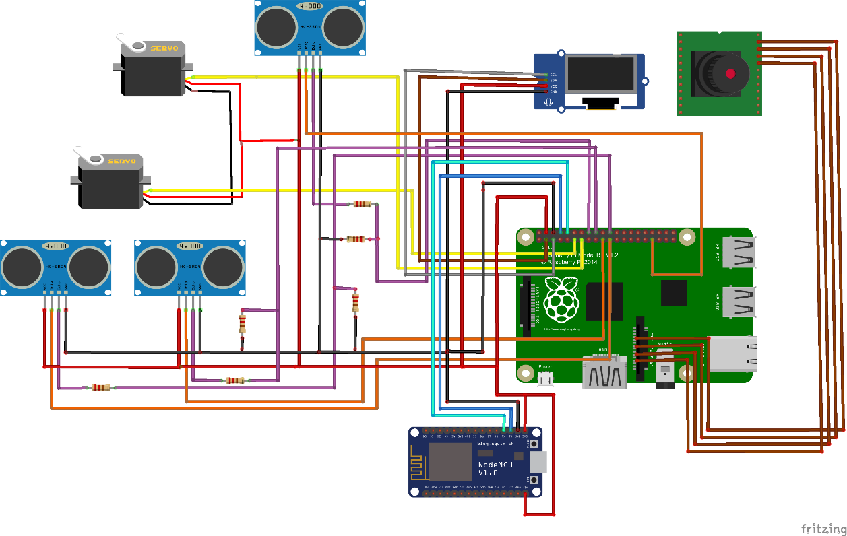*Skema Elektronik .**
* ***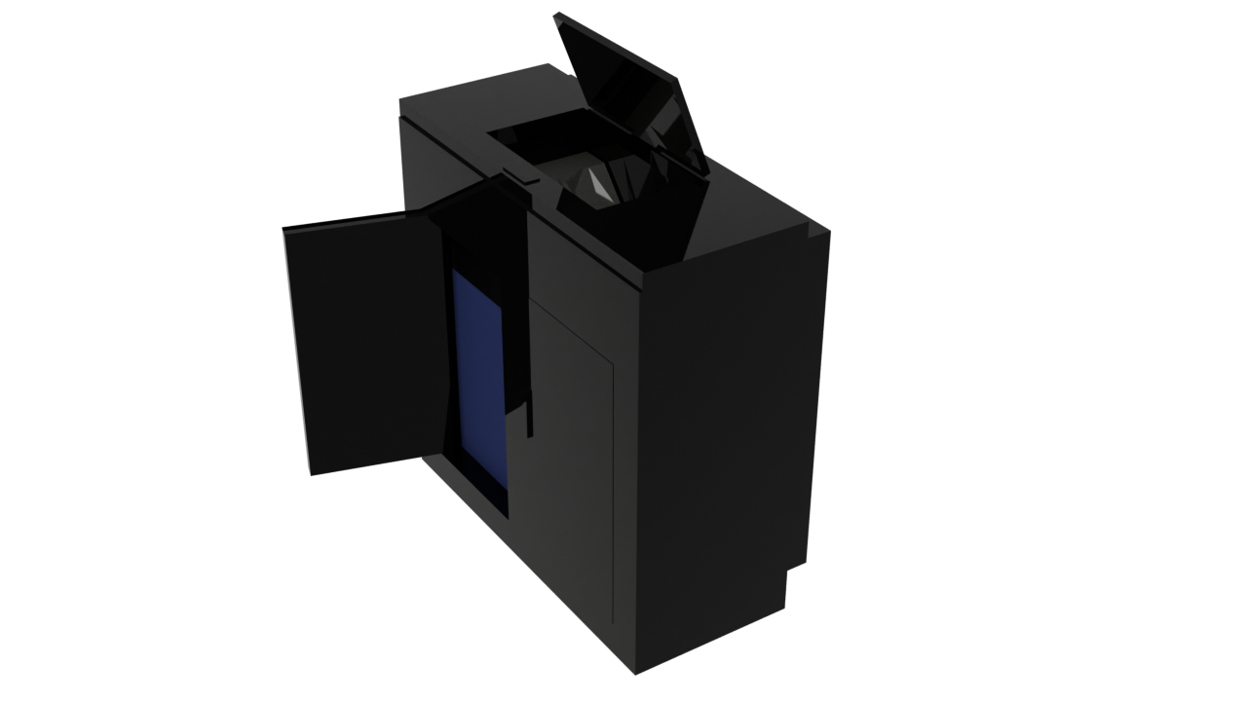*Desain Perangkat Keras .**
* **BOM .**

|  |  |  |  |  |
| --- | --- | --- | --- | --- |
| No. | Nama Item | Qty | Harga per Buah | Harga Total |
| 1 | **Raspberry pi** | **1** | **Rp.1.700.000,00** | **Rp.1.700.000,00** |
| 2 | **Sensor ultrasonic HC-SR04** | **3** | **Rp.15.000,00** | **Rp.45.000,00** |
| 3 | **Motor servo** | **2** | **Rp.50.000,00** | **Rp.100.000,00** |
| 4 | **Oled display 164x28** | **1** | **Rp.40.000,00** | **Rp.40.000,00** |
| 5 | **Mini camera sensor** | **1** | **Rp.85.000,00** | **Rp.85.000,00** |
| 6 | **Tempat sampah biasa** | **2** | **Rp.20.000,00** | **RP.40.000,00** |
| 7 | **Cassava bag large pack** | **1** | **Rp.150.000,00** | **Rp.150.000,00** |
| 8 | **Matex 1 kg** | **1** | **Rp.20.000,00** | **Rp.20.000,00** |
| 9 | **Balok kayu 5x5 100cm** | **10** | **Rp.5.000,00** | **Rp.50.000,00** |
| 10 | **Papan mdf 6mm 30 x 40** | **12** | **Rp.7.500,00** | **Rp.90.000,00** |
| 11 | **Sekrup m4x20 pack** | **1** | **Rp.6.000,00** | **Rp.6.000,00** |
| 12 | **Cat kayu 1kg glossy** | **1** | **Rp.40.000,00** | **Rp.40.000,00** |
| Total biaya | | | **Rp.2.326.000,00** | |

* ***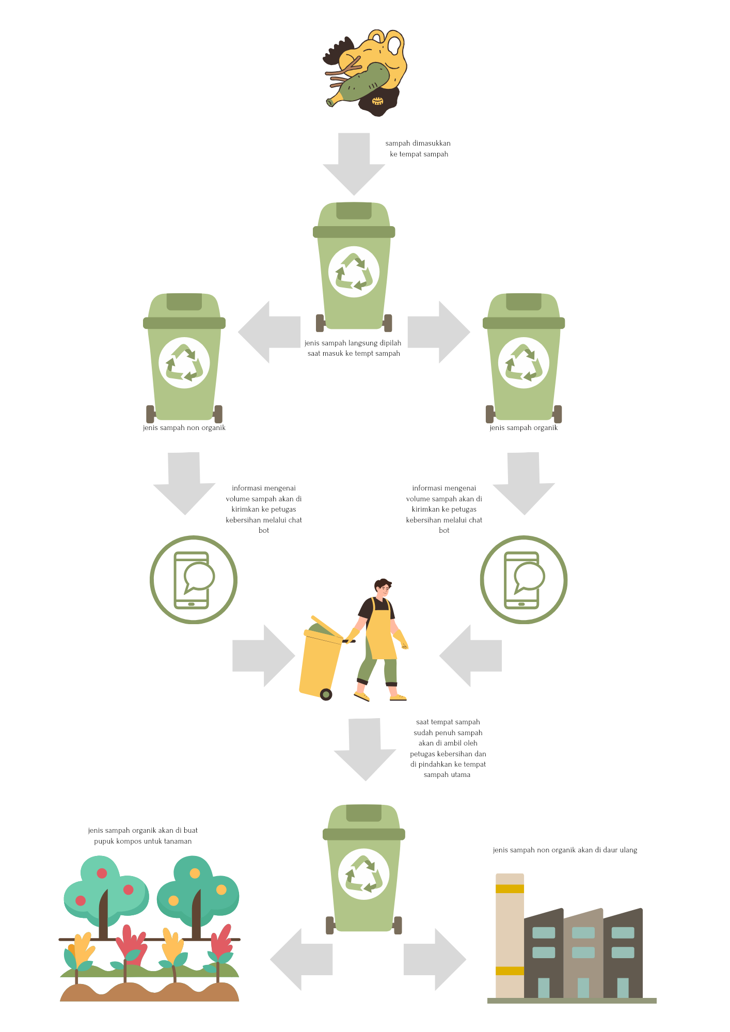*Flow Chart .**

**Nama : Slamet Nugroho .**

**Sekolah : SMKN 7 Semarang .**

**Kelompok : 234 .**